**ASYNC CALCULATOR PROGRAM**

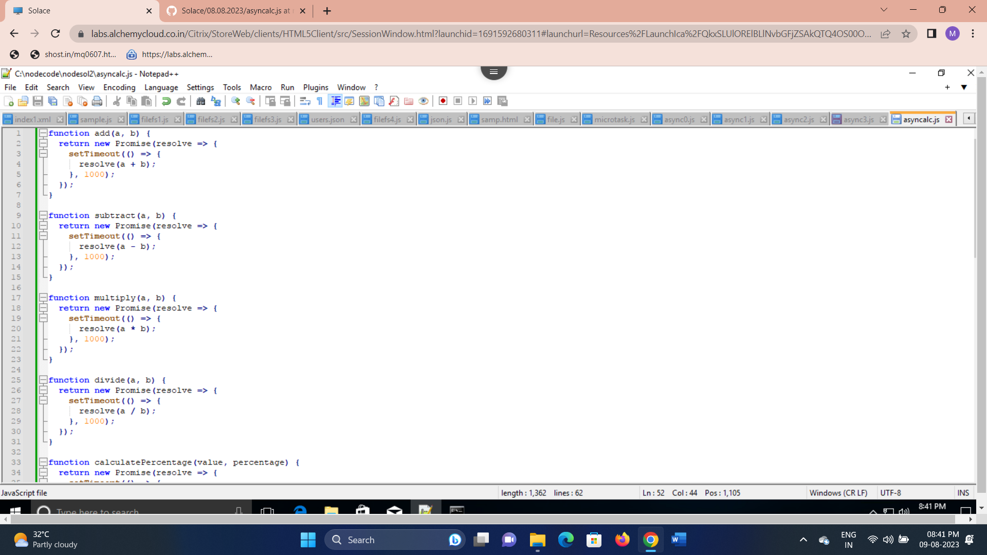

**OUTPUT**

